Fishing Tourism Business Planning Strategy To Increase People's Income in Lancang Island, Kepulauan Seribu
Mega Fitriani Adiwarna Prawira¹∗, Beta Budisetyorini², Amran Mansydea Saing³, Arinka Puti Dheandra⁴, Azzahra Intan Shavira⁵, Dzaky Huda Ari Sumenang Putra⁶, Prita Aziziya⁷
Abstract
1-7Sekolah Tinggi Pariwisata Bandung*

Received 12 July 2021
Accepted 22 July 2021
Lancang Island is one of the islands in the Kepulauan Seribu Regency with the potential for tourism and fishing activities. Some residents of Lancang Island took advantage of the opportunity by establishing a fishing charter business. This study aims to provide a proper planning strategy for the tourist business unit to increase public income on Lancang Island. The fishing tourism business in Lancang Island includes four units such as Fishing Charter, Boat Rentals, Catering, and Accommodation. The data used are primary and secondary, and the research method is qualitative and presented descriptively. According to research using the BCG Matrix, the entire fishing charter units on Lancang Island are in the Cash Cow quadrant, so concentric diversification is a viable planning strategy. The planning strategies consist of product planning, market, and marketing planning, and technology planning tailored to each business unit.

Keywords: Tourism Destination Island, Fishing Charter Business, BCG Matrix, Planning Strategy

INTRODUCTION
Lancang Island is one of the islands in The Kepulauan Seribu Regency to tourist attractions and fishing activities. Some part of its territory is a tourism development-based area. This island has interesting fishing spots such as charts and rumpons provided by residents, complete with various fish (beritapulauseribu.com 2018). Therefore, this becomes an attraction for tourists or fishing activities.
Thousand Islands Administrative District (2016-2020) shows increased tourist visits. In 2016 4,638 tourists were visiting Lancang Island, and in 2017 there was an increase to 9,095 tourists. In 2018-2019 tourists visiting Lancang Island reached more than 20,000, although, in 2020, the number of tourists decreased to 9,837 due to the Covid-19 pandemic.
Seeing these opportunities, some people of Lancang Island take advantage of the opportunity by opening a fishing tourism business to complement the needs of tourists during their activities in Lancang Island. Types of businesses fishing tourism businesses located in Lancang Island under the Regulation of the Minister of Tourism of the Republic of Indonesia Number 19 of 2015, among others are fishing package business, boat rental business, sales of fishing tackle equipment following the specifications of fishing techniques, and fishing tour guides.
In the preliminary study, fishing tourism affects the income of people in Lancang Island by 57.7%, while 42.3% is influenced by other variables that are not included in the study. The condition explains that the community as a business of fishing tour packages, restaurants, inns, and boat rentals shows the type of business influential in increasing the community's income in Lancang Island.

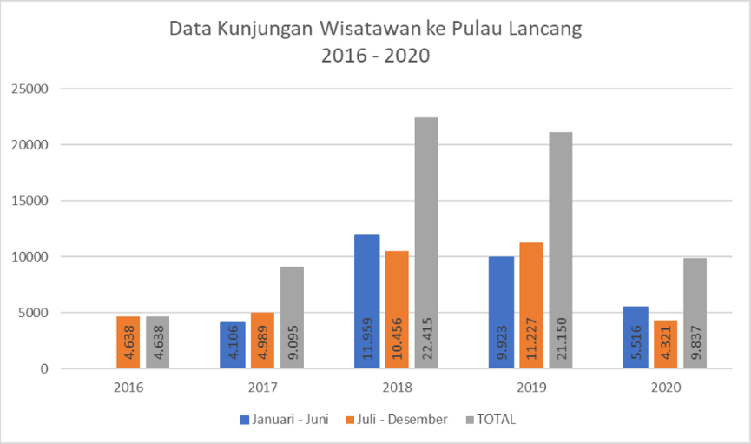

Figure 1. Lancang Island Tourist Visit Data (2016-2020)
Source: Suku Dinas Pariwisata dan Ekonomi Kreatif Kabupaten Administrasi Kepulauan Seribu
The fishing tourism business in Lancang Island still has problems such as decreasing tourist visits due to the Covid-19 pandemic. Tourists who are challenging to get information about fishing tourism activities do not have an organizational structure to manage fishing tourism activities, the absence of certified fishing tour guides, and the capacity of boats/boats that sometimes exceed the maximum limit of passengers. This research seeks to uncover the potential of fishing tourism in Lancang Island, which affects increasing people's income and the development problems of the fishing tourism business. The final objective of this research is to formulate the proper planning strategy for fishing tourism businesses to increase people's income in Lancang Island, Thousand Islands Administration Regency.

LITERATURE REVIEW
Fishing Tourism Business
Fishing tourism is one form of tourist activity involving the community in an archipelago tourist destination, the ability of local people to participate in economic activities related to tourism is said to appear at the stage of discovery and engagement (Butler, 1980). Referring to the Regulation of the Minister of Tourism of the Republic of Indonesia No 19 of 2015, the fishing tourism business aims to provide places and facilities for fishing activities using special equipment and safety equipment, including guide services, for recreational and entertainment purposes. In this research, the standard of fishing tourism business will focus on product aspects based on Regulation of the Minister of Tourism number 19 of 2015 as follows:

Table 1. Fishing Tourism Business Standards – Product Aspects

Elements | SUB ELEMENT
Fishing Package | The provision of fishing tourism activities, consisting of:  1. freshwater  2. saltwater
Fishing Tackle | Fishing tackle standards such as rod, reel, line, and hook.
Fishing Tour Guide | Have a certificate of competence
Supporting Facilities | - The reception area is equipped with clean and well-maintained tables and chairs.  - Provision of fishing boats and mooring areas, except in fishing ponds.  - Clean and well-maintained toilet.  - First Aid Equipment In Accidents (First Aid).  - Restaurant  - Inns
Source: Peraturan Menteri Pariwisata Nomor 19 Tahun 2015

Business Unit Planning Strategy - BCG Matrix
Boston Consulting Group analysis is a method used in developing a strategic business unit planning by classifying the potential profit of a business unit (Kotler, 2002). BCG matrix has four quadrants with two columns and two rows; 4 quadrants represent business unit product categories; from 2 dimensions of the BCG matrix, namely relative market share and market growth rate.
The horizontal axis indicates relative market share. Relative market share is part of the total sales of business units in a given market. The market share can be calculated relatively by the business unit's market share divided by the share of the largest competitors. The vertical axis represents the dimensions of market growth. Market growth is the projected sales rate for the market to be served. It is usually measured by a percentage increase in the value or volume of sales of the last two years.

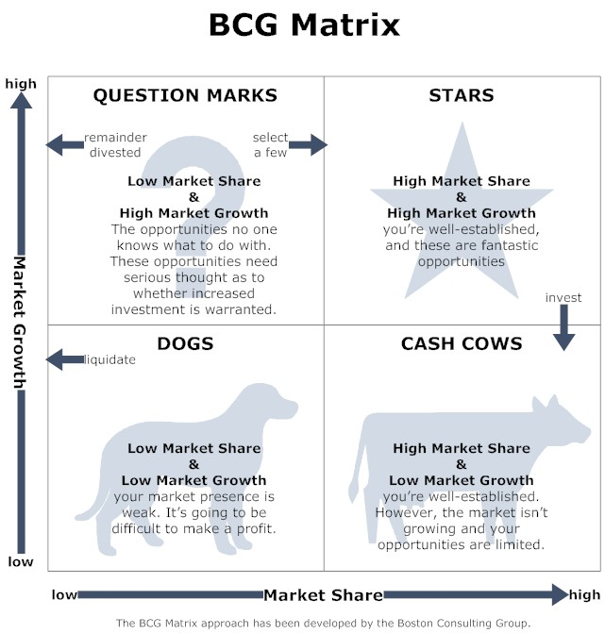

Figure 2. BCG MATRIX (David, 2006:299)
The category of BCG matrix, according to David (2006:298), is divided into four parts, including:
  - Question Mark: These business units have a relatively low market share in quadrant I, but they compete in a fast-growing industry. Usually, the cash needs of this business unit are high, and the cash income is low.
  - Star: Business unit in quadrant II, representing the organization's best long-term opportunities for growth and profitability. Divisions with relatively high market share and high industry growth rates should receive substantial investment to maintain or strengthen their dominant position.
  - Cash Cow: A potential business unit in quadrant III, has a relatively high market share competing in slow-growing industries. Called cash cows because they make more cash than they need, they are often milked. Many cash cows today are stars of the past. The dairy division must maintain its strong position for as long as possible. Based on the analysis, all fishing tourism business units in Lancang Island are quadrant III / cash cow.
  - Dog: Business units in quadrant IV have a relatively low market share, compete in low growth industries, or do not grow. Due to its weak internal and external positions, these business units are often liquidated, divested, and trimmed by retrenchment.
Boston Consulting Group guides that determining a planning strategy on a business unit allows a business unit to consider each division's relative market share position and market growth rate relative to other divisions within the organization. Therefore, researchers try to conduct research using the BCG matrix to know the relative market share and market growth rate. With this matrix, researchers can determine the appropriate planning strategy for the fishing tourism business unit in Lancang Island.

METHOD
This research is a research design that emphasizes qualitative research methods and presents descriptively. Sugiyono (2011:9) explained that qualitative research methods are based on the philosophy of postpositivism. It is used to research the condition of natural objects (as opposed to experiments) where researchers are a critical instrument, data collection techniques with triangulation (combined), data analysis is inductive or qualitative, and qualitative research results emphasize more meaning than generalization. According to Strauss and Corbin (2007:1), qualitative research is a type whose findings are not obtained through statistical procedures or other calculation forms. Although the data can be calculated and delivered in numbers, the data analysis is qualitative. Qualitative research refers to the analysis of non-mathematical data. This study produced findings obtained through data collected by various means, including interviews, observations, documents or archives, and tests.
While descriptive research, according to Sugiyono (2008), descriptive research is research conducted to know the value of independent variables, either one variable or more (independent), without making comparisons or connecting with other variables. Therefore, according to Creswell (2010), qualitative descriptive research includes the paradigm of post-positivistic research. Moreover, according to Ardianto (2010), the qualitative descriptive method of finding theory, not testing the theory; hypothesis-generating, not hypothesis testing, and heuristic not verification.
All data types relevant to the topic will be utilized to support the analysis process. An analysis unit is a unit that can be an individual, group, object, or background of social events such as individual or group activities as a research subject (Hamidi, 2010). Thus the analysis unit is what the researcher wants to analyze. The unit analysis in this study is 57 fishing tourism businesses in Lancang Island and fishing tourism businesses located in Pari island Thousand Islands Administration Regency as competitors.

Data Collection
Data collection is done through primary and secondary data collection. This data was obtained through several methods, namely the study of literature by using journals and books as enrichment, sources, and information related to data for the depth of the study related to the topic of research on the strategy of fishing tourism business planning to increase the income of the community in Lancang Island. The research team conducted field observations through observation and recording of data related to the topic of research, then interviewed with several stakeholders related to research topics such as the Tribe of Tourism and Creative Economy Administration Of Thousand Islands, The Tribe of Marine Food Security and Agriculture Administration of Thousand Islands, fishing tourism businesses in Lancang Island and another part fishing tourism businesses as competitors. Researchers interviewed 29 out of 57 fishing businesses due to limited observation time and unreachable businesses. The last checklist was used to identify research topics related to fishing business planning strategies to increase people's income in Lancang Island.

RESULTS AND DISCUSSIONS
Business Condition Analysis
The research team used a 1:1 data comparison by looking for information on the Lancang Island fishing tourism business unit, which has the same characteristics as the fishing tourism business unit in Pari Island. Here is the calculation of the sales volume of fishing tourism business units between Lancang Island and Pari Island:

Table 2. Relative Market Share and Sales Volume Calculation
No | Business Unit Name | Location | Sales Volume | PPR
1 | Fishing Tour Packages | P. Lancang | 57.600.000 | 1,71
 |  | P. Pari | 33.600.000
2 | Boat Rental | P. Lancang | 28.800.000 | 1,37
 |  | P. Pari | 21.000.000
3 | Inn/Homestay | P. Lancang | 36.000.000 | 1,5
 |  | P. Pari | 24.000.000
4 | Restaurant | P. Lancang | 219.000.000 | 1,09
 |  | P. Pari | 200.750.000
Source: processed research data,2021
The result data of the relative market share of tourism business units above indicates that the tourism business unit in Lancang Island has a higher market share than competitors. It causes by the higher the market share value of fishing tourism business units in Lancang Island, the more significant the proportion of the market it controls.
Table 3. Sales Volume and Market Growth Rate Calculation Results
No | Business Unit Name | Year |  | TPP
 |  | 2019 | 2020
1 | Fishing Tour Packages | 57,600,000 | 28,800,000 | -50%
2 | Boat Rental | 28,800,000 | 3,200,000 | -88,88%
3 | Inn/Homestay | 36,000,000 | - | -100%
4 | restaurant | 219,000,000 | 54,700,000 | -75%
Source: processed research data,2021

Considering the data, fishing tourism business units (table 3) show that all fishing business units in Lancang Island have decreased. It happened because of the Covid-19 pandemic that caused a decrease in tourists traveling to Lancang Island. Seeing this, all fishing tourism business units in Lancang Island must do some planning strategies to overcome this. Based on the analysis of market share and the growth rate of fishing tourism business units in Lancang Island, it can be found that the fishing tourism business unit is located in quadrant III, "CASH COW," as shown in figure 4.

Figure 4. Matrix BCG Fishing Tourism Business Unit in Lancang Island
Source: processed research data, 2021
This quadrant is called cash cows because business units generate more cash than needed. In this position, the concentric diversification strategy will be applied to all fishing tourism businesses in Lancang Island, namely, fishing package business units, ship rental business units, lodging business units, and restaurant business units.

Strategy Options
Strategies that can be used, namely:
- Product Planning Strategy
- Business Unit of Fishing Tour Package: 1) Improving the quality of fishing tourism and strengthening ties in community organizations by establishing SOP during activities, conducting training and certification of tour guides, and socializing CHSE;2) Innovating attractiveness and activities by making varied tour packages, cultivating various types of fish and holding fishing festivals to bring tourists.
- Ship Rental BusinessUnit: 1) Improving the quality of facilities and improving services and security by establishing SOP during activities onboard, conducting periodic ship certification testing, and conducting CHSE;2) Improving the quality of community organizations by conducting service training and building stronger ties in community organizations.
- Restaurant BusinessUnit: 1) Developing culinary centers by organizing, managing, and making standard culinary centers in Lancang Island; 2) Improving restaurant facilities by increasing the capacity of benches and providing handwashing; 3) Conducting restaurant management assisted by conducting management training and Management of food and drink products.
- Homestay BusinessUnit: 1) Improving the quality and facilities of homestays by conducting training to businesses on homestay management and conducting periodic facility inspections; 2) Establishing community organizations to be a forum for businesses to overcome the limitations of self-reliance and individual capabilities of businesses.
- Market Planning and Marketing Strategy
In this strategy, the four business units have similar strategies that can be applied, namely determining the target market, increasing promotional activities, increasing partnerships to conduct promotions, and developing promotions. From the strategy, the action plan that can be done as 1) Implementing marketing strategies in four business units with the concept of STP (Segmenting, Targeting, Positioning); 2) Conducting training and mentoring on digital marketing and Management to businesses:3) Cooperating with the government and travel agents to increase tourist visits.
- Strategi Planning Technology
In this strategy, the four business units have similar strategies that can be applied, namely improving the utilization of technology systems by conducting mentoring and training to businesses on digital marketing and social media management. Businesses can create a website or use social media, Instagram, or Facebook to facilitate tourists getting information and making reservations.

CONCLUSION
The development of fishing tourism business units in Lancang Island since its establishment in 2021 shows the readiness to receive tourists. The growing quantity of actors characterizes the gradual increase. Revenues decreased in 2020 due to the circumstances and situation of Covid-19, which led tourists to cancel their intention to travel. The relative market share indicates that the entire fishing tourism business unit in Lancang Island has a relatively higher market share than competitors. It signifies that the fishing tourism business unit in Lancang Island controls total sales or a more significant market area than competitors or can be called a market leader. This condition can become an advantage because each business unit with a higher market share value usually generates much revenue, and costs that the business unit must incur are lower while the market growth rate shows a decrease.
Based on calculating relative market share and market growth rate, all fishing tourism business units are in the third quadrant of a cash cow. This condition means concentric diversification strategy is the proper planning strategy used by all business units in Lancang Island to achieve a strategic position. The strategy will be applied to all existing business units, including fishing package business units, ship rental business units, lodging business units, and restaurant business units. The planning strategy consists of product, market, marketing, and technology planning that suits each business unit.

ACKNOWLEDGMENT
The research team thanked the support of the Ministry of Tourism and Creative Economy of the Republic of Indonesia, the Provincial Government of DKI Jakarta, the Department of Tourism and Culture of DKI Jakarta Province, the Village and the community in Lancang Island, as well as all parties who contributed to this study.

REFERENCES
Ardianto, Elvinaro. 2010. Metodologi Penelitian Untuk Public Relations Kuantitatif dan Kualitatif. Bandung: Simbosa Rekatama Media.
Badan Pengelola Lingkungan Hidup Daerah Provinsi Daerah Khusus Ibukota Jakarta. (2014). Ekoregion Laut Provinsi Daerah Khusus Ibukota Jakarta : 208 hlm.
Basrowi & Suwandi. 2008. Memahami Penelitian Kualitatif. Jakarta: Rineka Cipta
Budisetyorini B., Prawira M.F.A., Saing A.M., Dheandra A.P., Shavira A.I., Putra D.H.A.S., dan Aziziya P. 2021. Wisata Memancing dan Pendapatan Masyarakat di Pulau Lancang Kabupaten Administrasi Kepulauan Seribu. Program Studi - Studi Destinasi Pariwisata, Sekolah Tinggi Pariwisata Bandung.
Butler, R.W. (1980). The Concept of Tourism Area Cycle of Evolution: Implications for the Management of resources. Kanada: University of Western Ontario.
Creswell, J.W. (2010). Research Design: Pendekatan Kualitatif, Kuantitatif, dan Mixed. Yogyakarta: PT Pustaka Pelajar.
David, F., R. (2006). Manajemen Strategis : Konsep. Edisi Sepuluh. Jakarta: Salemba Empat.
Hamidi. (2010). Metode Penelitian Kualitatif. Malang: UMM Press.
Karyono, A. H. (1997). Kepariwisataan. Jakarta : Grasindo.
Philip, K. (2002). Manajemen Pemasaran Edisi Millenium Jilid 2. Jakarta. PT Prenhallindo.
Moleong, L. J. (2013). Metode Penelitian Kualitatif. Edisi Revisi. Bandung : PT. Remaja Rosdakarya.
Pawson, M. G., Tingley, D., Padda, G., & Glenn, H. (2007). EU Contract FISH/2004/011 on "Sport Fisheries" (or Marine Recreational Fisheries) in the EU. CEFAS.
Pendit, N. S. (2006). Ilmu Pariwisata (Sebuah Pengantar Perdana). Jakarta: PT. Pradya Paramita.
Peraturan Menteri Pariwisata. (2015). Tentang Standar Usaha Wisata Memancing. Jakarta: Kementerian Pariwisata RI.
Peraturan Daerah Provinsi Daerah Khusus Ibukota Jakarta (2004). Tentang Pembentukan Kecamatan Kepulauan Seribu Utara dan Kecamatan Kepulauan Seribu Selatan Kabupaten Kepulauan Seribu4 tahun 2001 tentang Pembentukan Kecamatan Kepulauan Seribu Utara dan Kecamatan Kepulauan Seribu Selatan Kabupaten Kepulauan Seribu. Jakarta: Gubernur Provinsi Daerah Khusus Ibukota Jakarta.
Putrajaya, Geseng. (2010). Peran Positif Modal Sosial Nyambang Sebagai Alat untuk Mengatasi Peningkatan Kemiskinan Masyarakat Nelayan Pulau Lancang Kel. Pulau Pari, Kec. Kep Seribu Selatan, Provinsi DKI Jakarta. Skripsi. FE. Perencanaan dan Kebijakan Publik. Universitas Indonesia.
Sachoemar, S. I. (2008). Evaluasi Kondisi Lingkungan Perairan Kepulauan Seribu. JRL Pusat Teknologi Pertanian Badan Pengkajian dan Penerapan Teknologi (BPPT) 1 (4): 19-26 ISSN: 2085-3866.
Sarjono, H., & Kuncoro, E. A. (2013). Analisis Matrix Boston Consulting Group (BCG) Untuk Memenangkan Strategi Organisasi (Studi Kasus Perguruan Tinggi di Kopertis Wilayah - III DKI Jakarta). Business Binus Review, 1 (4), 414-42.
Sugiyono. (2018). Metode Penelitian Kuantitatif Kualitatif dan R&D. Bandung: Alfabeta.
Suparwoko. (2010). Pengembangan Ekonomi Kreatif Sebagai Penggerak Industri Pariwisata. Simposium Nasional 2010: Menuju Purworejo Dinamis dan Kreatif. Yogyakarta: Universitas Islam Indonesia.
Suwarsono. (1996). Manajemen Strategik: Konsep dan Kasus, Edisi Revisi. Yogyakarta: UPP AMP YKPN.
Strauss, Anselm dan Yuliet Corbin. 2007. Dasar-dasar Penelitian Kualitatif. Yogyakarta: Pustaka Pelajar.
Tantowi, A., Barudin, Suryani, E., & Basuki, R. (2019). Neraca Satelit Pariwisata Nasional (NESPARNAS) 2017. Jakarta: Badan Pusat Statistik.
Tim Dosen Pengampu PD 2. (2009). Handout Observasi. Fakultas Psikologi
Universitas Islam Negeri Maulana Malik Ibrahim Malang
Yoeti, Oka A. (1985). Pemasaran Pariwisata. Bandung: Angkasa.
Yuliandi, F. (2019). Ekosistem Perairan, Suatu Konsep Kesesuaian dan Daya Dukung Wisata Bahari dan Wisata Air Tawar. Bogor: PT Penerbit IPB Press.
Zed, Mestika. (2008). Metode Penelitian Kepustakaan. Jakarta : Yayasan Obor Indonesia.

Correspondence address: Mega Fitriani Adiwarna Prawira Email : megafitriani@stp-bandung.ac.id Address : Jl. DR. Setiabudhi 186 Kota Bandung

